CSE 241 OOP HOMEWORK 2 PRESENTATION DOCUMENT
In this pdf document, I will briefly explain the assignment to you with examples about the purpose of the codes, the uml diagram, the output of the code.

In this assignment, it was an assignment in which we made the classes we created in the previous homework 1 virtual and added new features. Let's start the presentation by showing the UML diagram of this assignment.
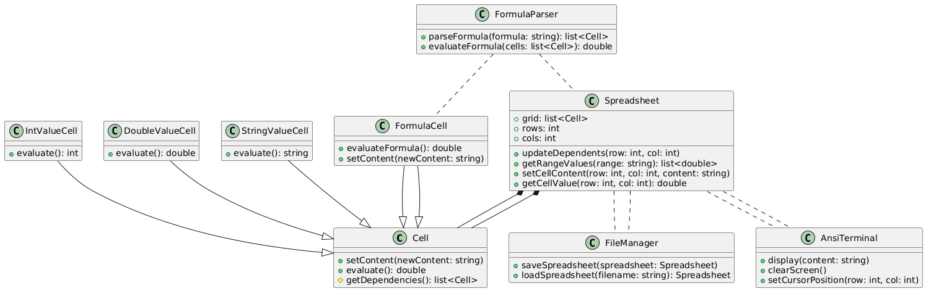
As you can see, it contains a very complex UML diagram.
Let's start with the cell class first:
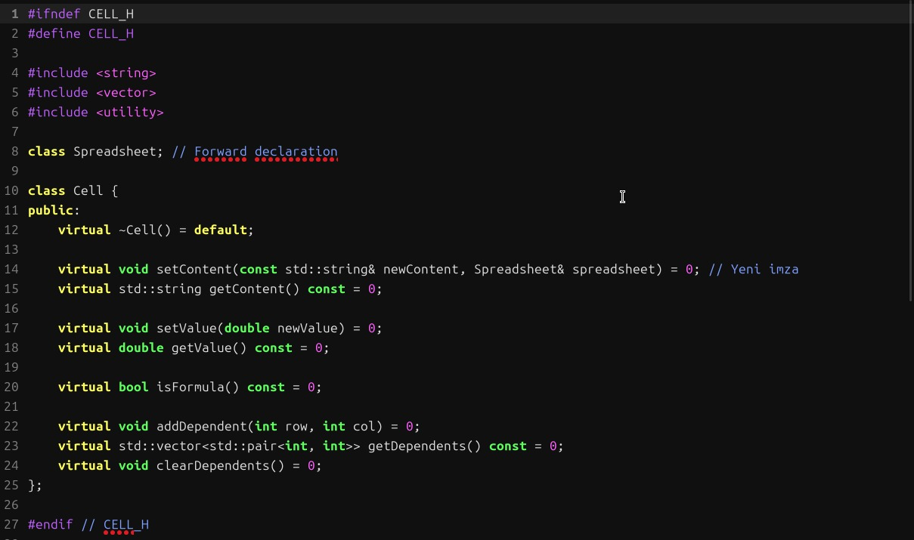
This code defines an abstract class (Cell) for modelling spreadsheet cells and forms the basis for four different classes (e.g. text cell, number cell, formula cell, etc.).

Header Guard: Prevents the file from being included more than once.
Libraries: Manages cell content (string) and dependencies (vector<pair<int, int>>).
Main Functions:
Content and value management (setContent, getValue, etc.).
Formula control (isFormula).
Handling cell dependencies (add, get, clear).
This structure provides an interface that defines the basic behaviour of cells.

Here are brief descriptions of the classes derived from the Cell class according to the given project requirements:

IntValueCell:
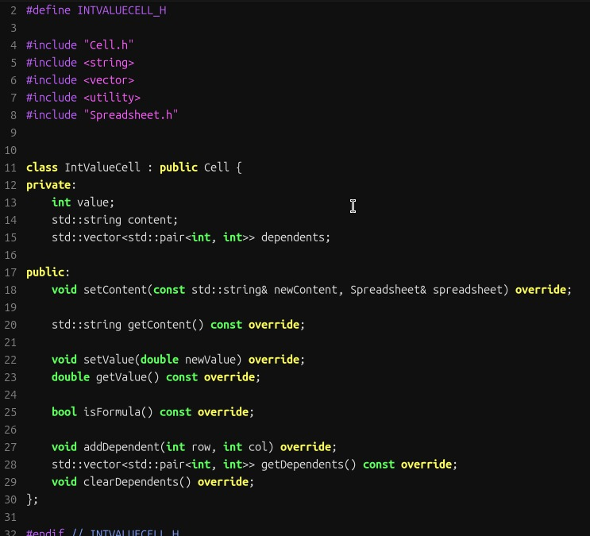
Objective: A class of cells representing integer values.
Properties: Stores and processes only integer values in the cell.
Behaviour:
The setValue and getValue functions work only with the int type.
Does not contain a formula (the isFormula function returns false).

DoubleValueCell:
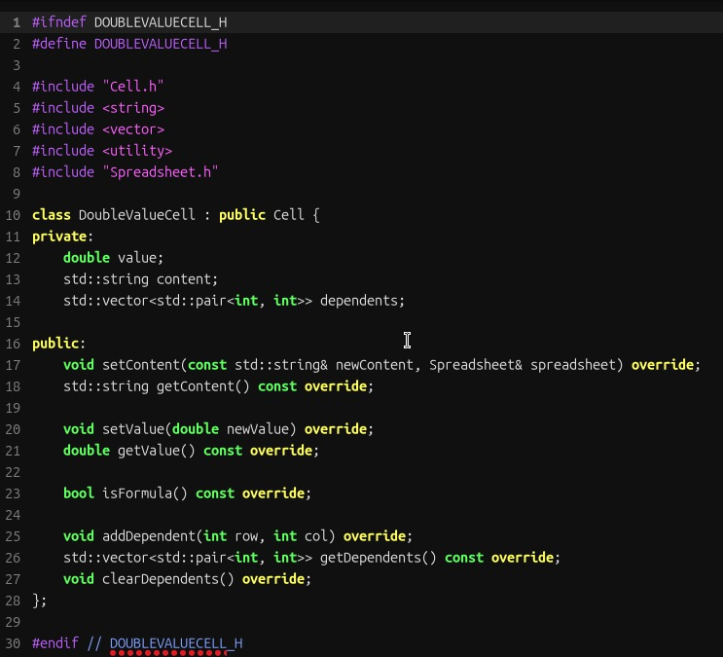
Purpose: A class of cells representing floating-point decimal values.
Properties: Stores and manipulates decimal values in the cell.
Behaviour:
The setValue and getValue functions only work with the double type.
Suitable for calculations requiring high accuracy.
Does not contain a formula (isFormula returns false).

StringValueCell:
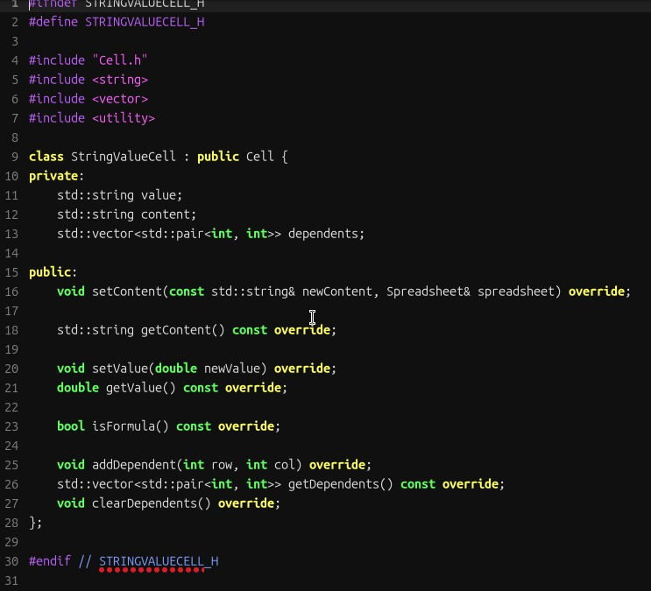
Purpose: A class of cells representing text (string) values.
Properties: Stores only text values in the cell.
Behaviour:
The setContent and getContent functions organise the cell content as text.
Does not contain values (doubles), only textual content.
Does not contain a formula (isFormula returns false).

FormulaCell:
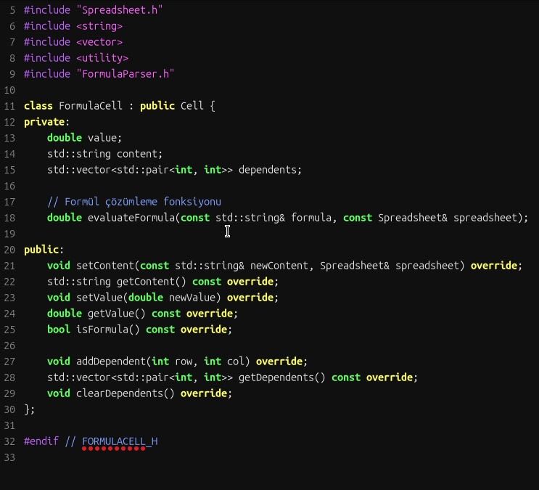
Purpose: A class of cells representing formulae and calculations.
Properties: Stores and evaluates a formula (e.g. =A1 + B2) in a cell.
Behaviour:
Works with the formula parser.
The setContent function gets the formula as text.
The getValue function returns the result of the formula.
Manages dependents, because formulas can reference other cells.
isFormula returns true.
These classes extend the interface provided by the Cell class to support different data types and behaviours. This structure provides the basis for a flexible spreadsheet implementation in the project.

FormulaParser:
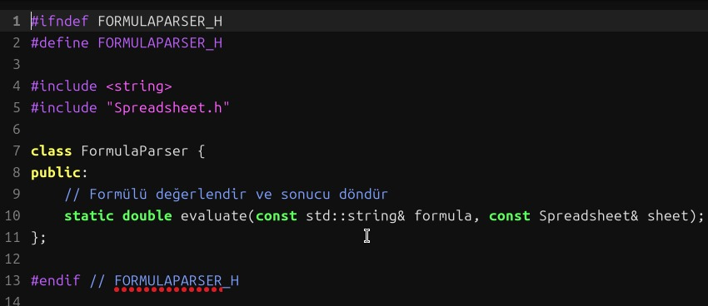

This script calculates and returns the result of a formula in a cell.
Analyse Formula: Parses cell references (e.g. A1) and numbers within the expression by removing the = sign.
Calculation: Applies basic mathematical operations (+, -, *, /). Gets the values of cell references from Spreadsheet.
Error Checking: Throws errors for division by zero and invalid formula entries.
Result: Returns the result of the operation as a double.
Example: =A1+3.5 -> takes the value A1, adds it to 3.5, returns the result.
Spreadsheet:
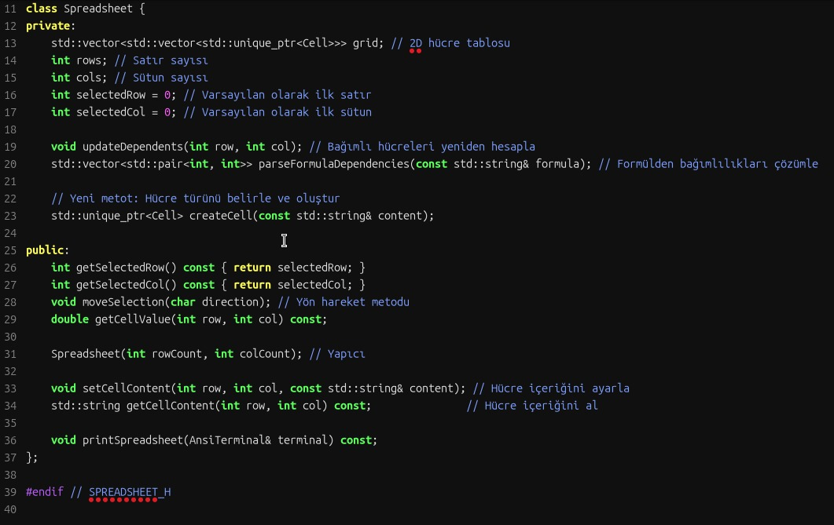
This script implements the Spreadsheet class in the spreadsheet application.
Main Functions:
Table Creation: Initialises a dynamic cell structure based on the number of rows and columns.
Cell Type Management: Creates the appropriate cell type (IntValueCell, FormulaCell, etc.) according to the content.
Dependency Management: Tracks the dependencies of formula cells and reflects changes to dependent cells.
User Interaction: Edits the contents of cells, displays the table in the terminal, and manages cell selection.
Formula Analysing: Parses formulas, solves cell references and makes calculations.
Assignment Importance
Dynamic Memory Management: Memory security is provided with smart pointers.
Abstraction: Cell types are derived from the Cell class to create an extensible structure.
Dependency Update: Formulas and dependent cells are updated automatically.
Terminal Interface: User interaction is supported.
This code is an important component that demonstrates the basic logic of the spreadsheet and modern C++ skills.

AnsiTerminal:
Function of Code
AnsiTerminal provides text colouring, positioning and user input management in a terminal-based interface.
Main Functions
Colour Management: Changes and resets text colour and prints coloured text.
Terminal Control: Clears the screen, prints text in a specific position or in reverse colour.
User Input: Detects single key and special key inputs (e.g. directional keys).
Constructor/Destructor: Prepares the terminal settings for input and returns them to their original state.
Importance
The terminal-based spreadsheet provides the basis for visuality (colour and positioning) and interactivity (user input).

FileManager:
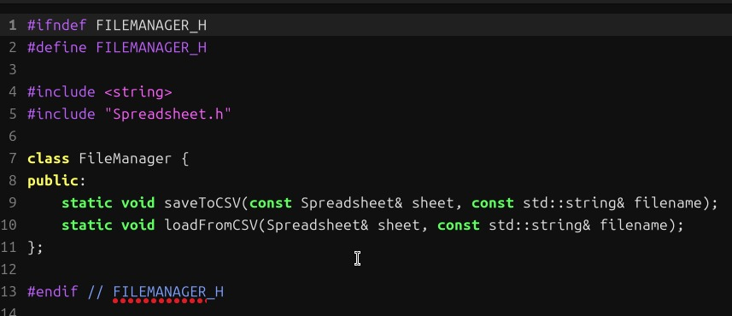
Function of Code
The FileManager provides the functions of saving and loading the spreadsheet as a CSV file.
saveToCSV: Saves the spreadsheet in CSV format by row and column.
loadFromCSV: Reads the CSV file, loads it into the table and updates the cell contents.
Importance
Provides data persistence, exports and reloads the table. With the CSV format, data becomes portable and easily usable.

Below is an output example, a value was entered into A1 and a value was entered into C1. Then =A1 + C1 was written to C2 cell and you can see the output below:You can see some outputs below:
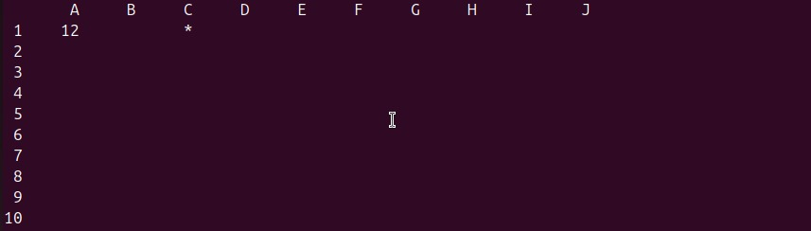
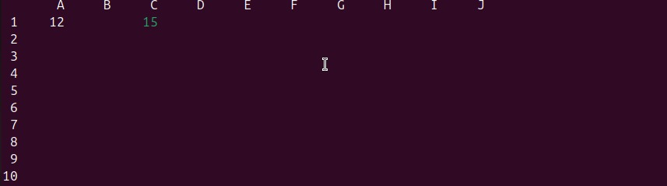
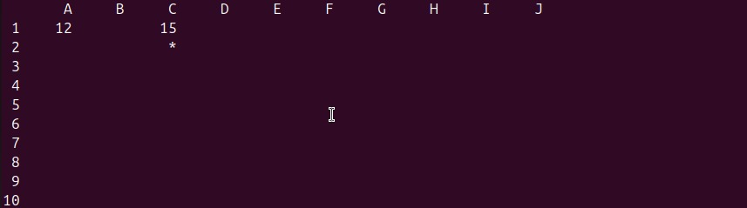
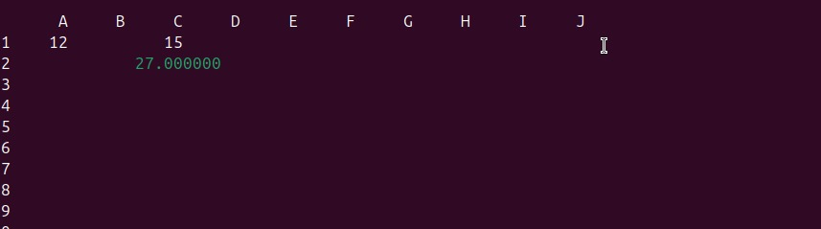
You will now see below how to export this code to a .csv document:
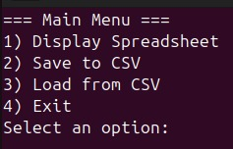
While in this section we click on 2
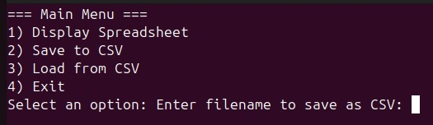
In this section, a file named .csv is written and the table is transferred there.
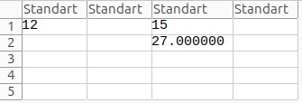
When creating the table from the .csv extension document, the 3rd option is selected and then the .csv file name is written.
Chatgpt-assisted sections:
I got help from Chatgpt ai in FormulaParser.h and FormulaParser.cpp.
Missing Sections:
In this assignment, there are a few deficiencies in Template, namespace and functions.
What I learnt and reinforced in this assignment:
Dynamic Memory and Smart Pointers

Data management with 2D dynamic array without using STL.
Memory management with smart pointers.
Abstract Class and Derivation

Cell abstract class and derivations such as FormulaCell, IntValueCell, StringValueCell, DoubleValueCell.
Namespaces

Logical namespaces for code organisation (Spreadsheet, Utils).
Error handling

C++ exceptions for formula errors, overruns and file operations.
Templates

Use templates for reusable components (Range, Grid).
Formula Processing

Formula parsing and calculation supporting operators and functions.
File Operations
Saving and loading tables in CSV format.
Visual Interface

A text-based, visual and interactive interface with ANSI terminal
Thanks for everything…

